SELENIDE DEMO REPORT

Purpose of this document: This document explains the steps done to check whether the application is working properly using Selenide. It covers page loading, product page validation, and basic actions like adding a product to cart.

Prepared By : V Ajay Krishnan

1.Objective
The objective is to check:
The objective is to check:
• Whether the page loads correctly
• Whether the product page is opened properly
• Whether the user can add a product to cart
- Whether the user is able to see In stock

2.Environment & setup

Language used: Java
OS: Windows
Tool: Selenide
Configurations:
• Base URL: http://localhost:5173
• Browser: Chrome
• Headless: false
• Browser Size: 1440x900
• Timeout: 10000 ms

3.Framework design
The framework is designed using simple class structure:
• BasePage: Used for opening pages and checking if page is loaded
• ProductPage: Used for product related actions like verifying product and adding to cart
• Config: Contains browser and execution settings

4.Project structure
APP
pages
------BasePage.java
------ProductPage.java
support
------SelenideConfig.java

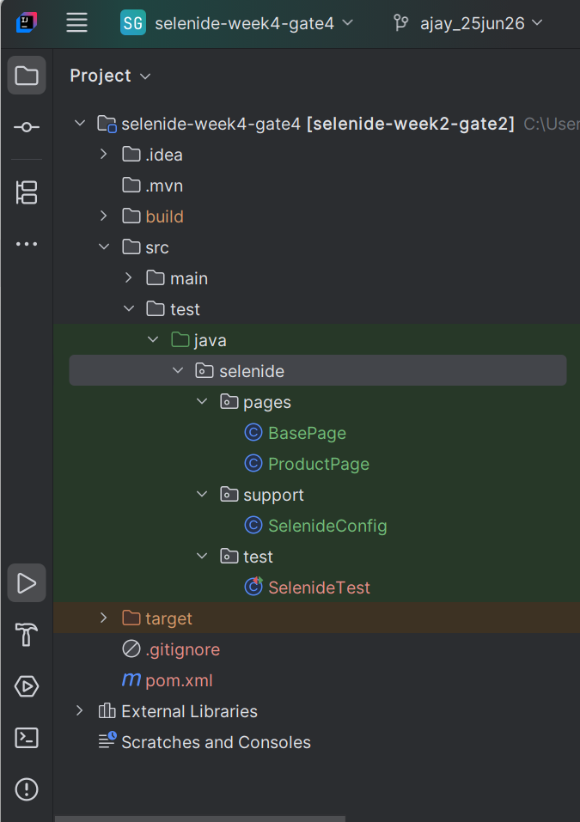

5.How to Run Commands

mvn clean test

mvn -Dtest=SelenideTest test

6.STEPS PERFORMED
1.Open the application using open() method
2.Verify the page is loaded using a locator
3.Open the product page
4.Check if the product name is visible
5.Click on Add to Cart button
6.Check product availability using locator

7. Test Cases Executed
1.Product Page Test
• Verified:
Page is loaded
Product name is visible
Add to cart button is clickable
2.Add to Cart Test
• Verified:
User is able to click Add to Cart
Product availability shows In Stock

- 8.Result
Total Test Cases: 1
- Passed: 1

The testcase has been successfully passed and user is able to see the availability In Stock
8.Conclusion
The application flow is working as expected.
Page loading, product validation, and add to cart action are verified and Availbailty of the product is also checked.
The code is simple and reusable with Selenide classes.

9.Evidence

Screenshots attached separately showing:
- Successful test execution

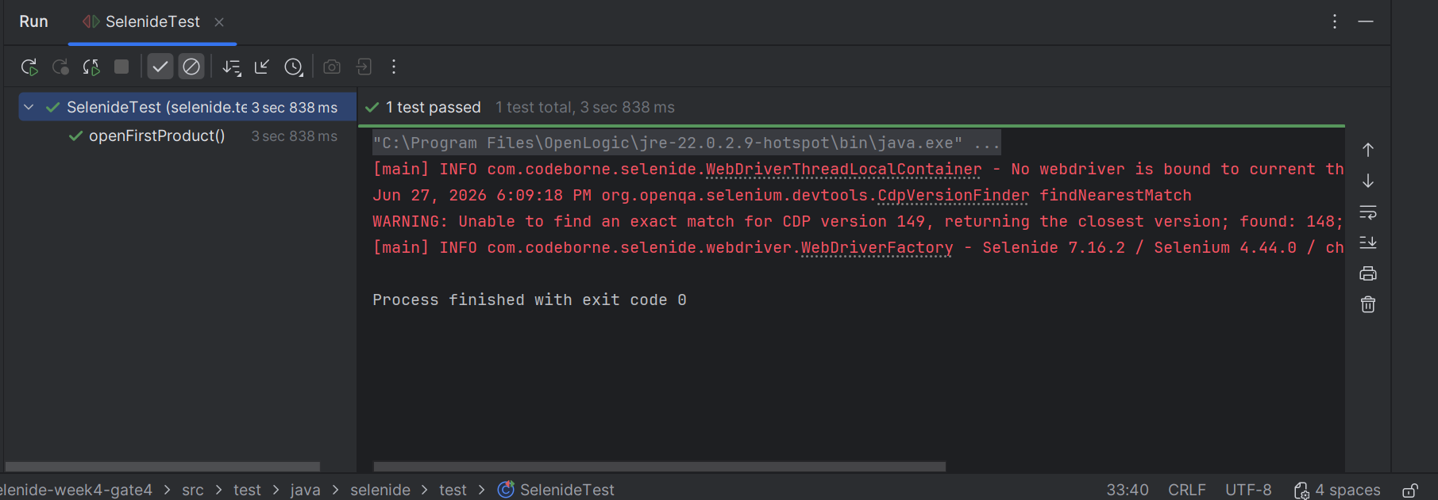

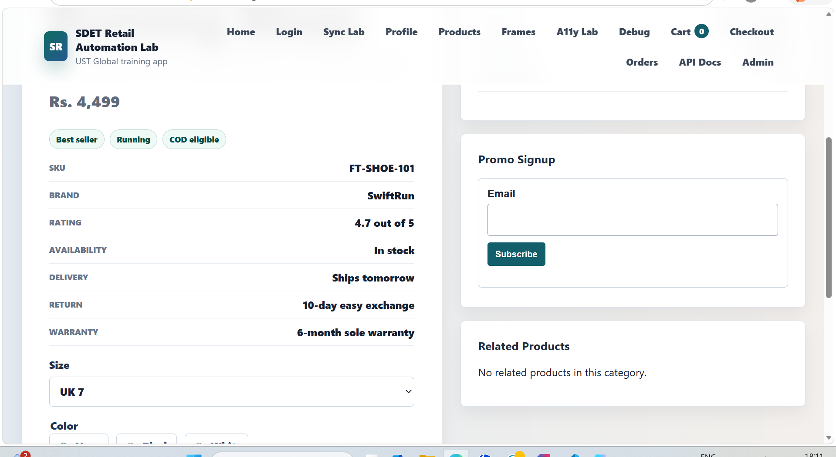

PACT DEMO REPORT

Purpose of this document: This document explains the steps done to test the OMS service using Pact. It verifies the communication between consumer (POS) and provider (OMS) using contract testing.

Prepared By : V Ajay Krishnan

1.Objective

The objective is to check:
• Whether the consumer request is correct
• Whether the provider gives expected response
• Whether contract between POS and OMS is working
Both consumer and provider tests are executed.

2.Environment & setup

Language used: Java
OS: Windows
Tools used: Pact, WireMock
Configurations:
• Pact Broker URL: http://localhost:9292
• Provider Name: oms-provider
• Consumer Name: pos-consumer
• WireMock Port: 4010

3.Framework design
The framework is divided into:
• Consumer Test: Defines request and expected response using Pact
• Provider Test: Verifies the contract using WireMock
• Client Class: Handles API calls using Rest Assured

4.Project structure
1.Java
oms – OmsProviderVerification
pos – PosOmsConsumerPactTest
pso – OmsClient

2.Resources
Docker-compose-pact-broker.yml

3. .Github

Workflows:
consumer.yml
producer.yml

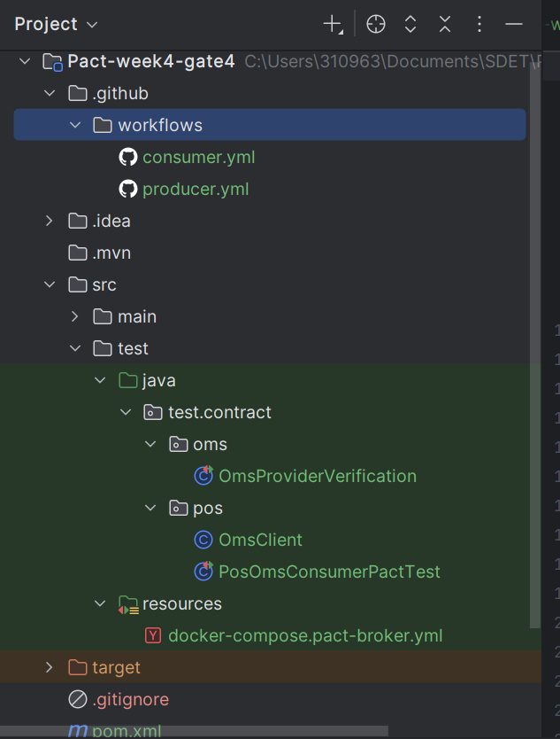

5.How to Run Commands

mvn clean test

mvn -Dtest=PosOmsConsumerPactTest test

mvn -Dtest=OmsProviderVerification test

6.STEPS PERFORMED

Consumer Side:
- Define contract for GET /order/10
- Define contract for POST /order
- Define contract for GET /product
- Send request using Rest Assured
- Validate response

Provider Side:
- Start WireMock server
- Stub API responses
- Match states from Pact
- Verify interactions using Pact

7. Test Cases Executed

Get Order Test
• Verified:
Status code 200
Order details returned
Create Order Test
• Verified:
Status code 201
Order created successfully
Get Product ID Test
• Verified:
Status code 200
Product id and status returned

- 8.Result
Total Test Cases: 3
• Passed: 3
- All consumer and provider tests passed successfully
8.Conclusion
The contract between POS and OMS is working correctly.
All API requests and responses are verified using Pact.
Consumer and provider are in sync.

9.Evidence

Screenshots attached separately showing:
• Consumer test execution
• Provider verification
• Pact contract generation

